**Practice Problems**

**P4.3-4.** Determine the values of the node voltages, *v*1, *v*2 and *v*3 in the circuit shown in Figure P4.3-13.

**Solution:**

First, express the resistor currents in terms of the node voltages:

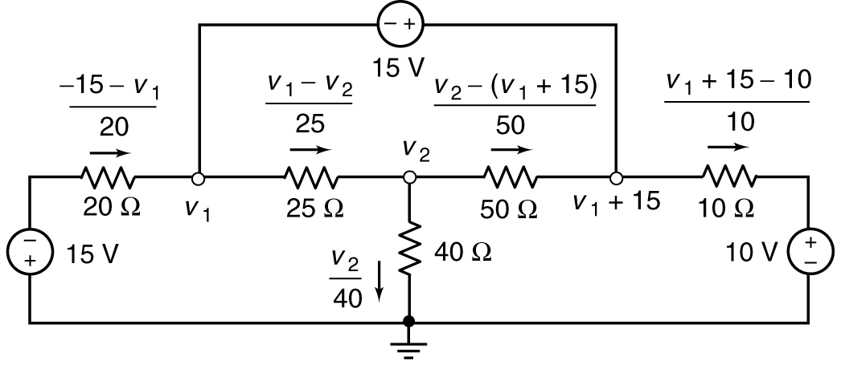

Apply KCL to the supernode to get



Apply KCL at node 2 to get 

In matrix form: 

Solving: 

*************************************************************************

**P 4.3-9**Determine the values of the node voltages of the circuit shown in Figure P 4.3-9.

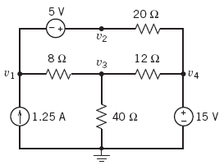

**Figure P 4.3-9**

**Solution:**

Express the voltage source voltages as functions of the node voltages to get



Apply KCL to the supernode corresponding to the 5 V source to get



Apply KCL at node 3 to get



Solving, e.g. using MATLAB, gives



So, the node voltages are:



**************************************************************************

|  |  |
| --- | --- |
| **P 4.4-16**The voltages *v*1, *v*2, and *v*3 in Figure P 4.4-16 are the node voltages corresponding to nodes 1, 2, and 3. The values of these voltages are  *v*1 = 12 V, *v*2 = 21 V, and *v*3 = –3 V  **(a)** Determine the values of the resistances *R*1 and *R*2.  **(b)** Determine the power supplied by each source. | **Figure P 4.4-16** |

**Solution:**

**(a)**  and 

**(b)** The power supplied by the voltage source is . The power supplied by the 1.25-A current source is . The power supplied by the 0.5-A current source is . The power supplied by the 2-A current source is .

|  |  |
| --- | --- |
| **P 4.6-8**Determine values of the mesh currents, *i*1, *i*2, and *i*3, in the circuit shown in Figure P 4.6-8. | **Figure P 4.6-8** |

**Solution:** Use units of V, mA and k. Express the currents to the supermesh to get



Apply KVL to the supermesh to get



Apply KVL to mesh 2 to get



Solving, gives



****************************************************************************

**P4.6-13** Determine the values of the mesh currents i1, i2 and i3 and the output voltage *v*o in the circuit shown Figure 4.6-13.

**Solution:** Notice thatthe current source are each in a single mesh. Consequently, *i*1 = 2.4 A and

*i*2 = 1.2 A. Label the resistor currents in terms of the mesh currents:

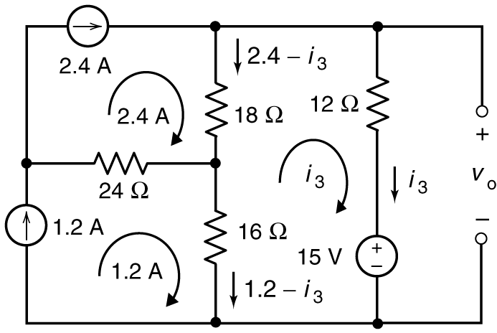

Apply KVL to mesh 3 to get



Apply KVL to the rightmost mesh to get

